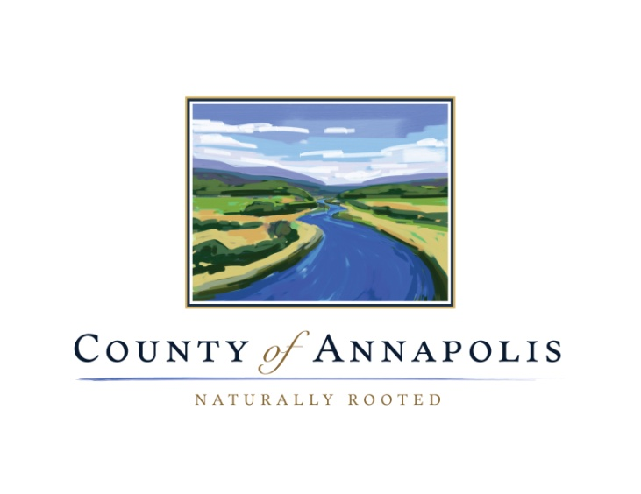

Comment Form

Margaretsville Source Water Protection Plan

- Do you live in the source water protection area?

- Do you use the municipal water supply?

- Are you aware of any significant threats to the source water supply that have not been identified? Can you add any information on identified potential contaminants?

- Have you experienced any water quality or quantity issues?

- Your local knowledge is important and valuable. Is there anything that may have been overlooked in assessing the potential risks the water supply?

- Please feel free to add any other comments you have concerning the Margaretsville Water Supply.

Please submit your comments by October 28th to the Municipal Office in Lawrencetown (396 Main St.)
Attn: Margaretsville Source Water Protection Advisory Committee

